Leapfrog Geo & Edge Workflow
Category Classification of a Blockmodel by RL
Reporting or visualising blockmodel by particular RL/Z Height ‘bins’ e.g. 20-30mRL is a common process in production, especially open pit mining. Using a combination of a distance numeric models and grouped meshes, we’ve found a quick method to categorise the relevant blocks for this method.
Note: The first method only works when the 0mRL plane is entirely above or below the model (see below) because the distance function output is bidirectional. If your 0mRL plane cuts through the middle of the model, please go to the second method, the main difference is the need for two distance models and renaming required at the category stage.
0mRL
Blockmodel
Second Method
0mRL
Blockmodel
First Method

First Method (Unidirectional RL):
- Establish a plane then mesh at your ‘0mRL’
  - Create a flat plane that spans the entire project areal X and Y, with room to spare. Ensure the Z is set to the 0 RL and the Dip is 0
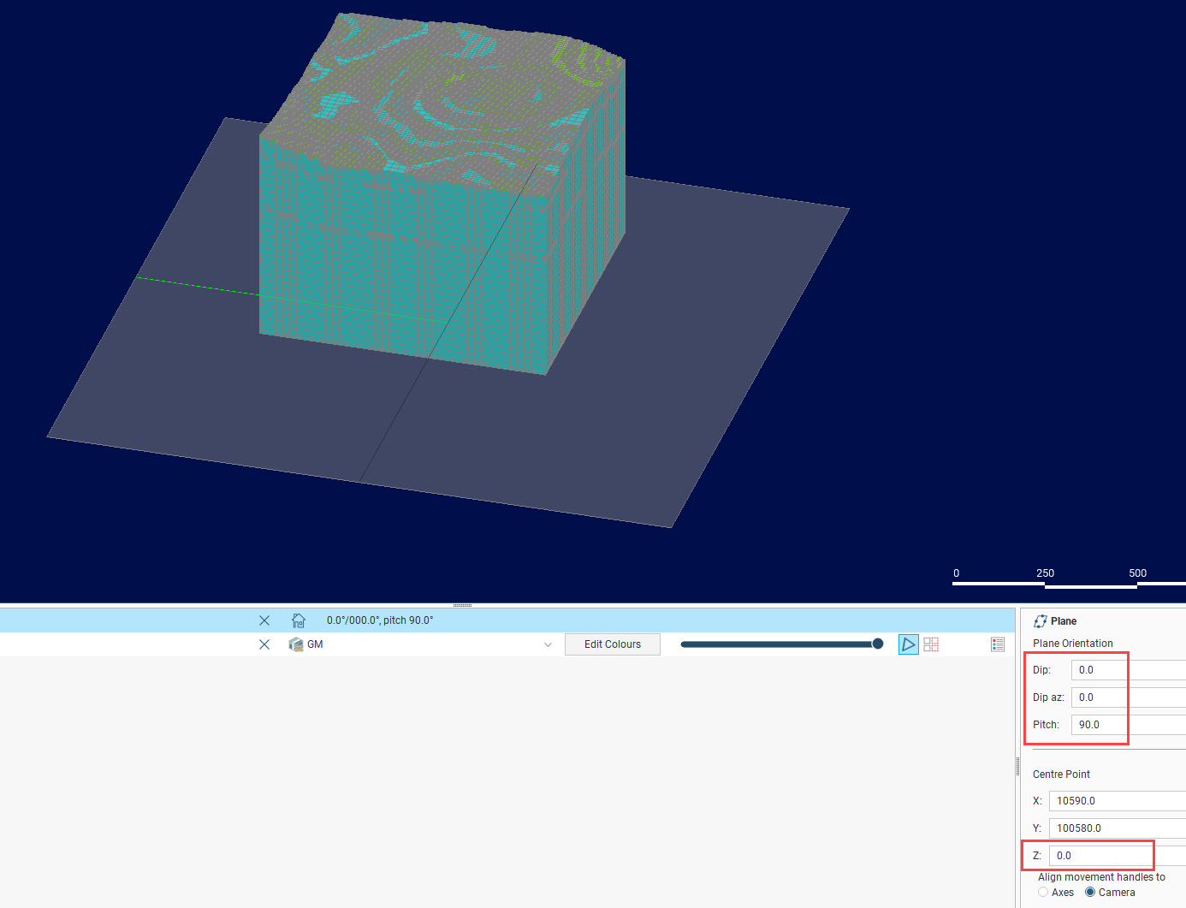
  - Right click on the Meshes à From Moving Plane. This will create a static mesh plane at the correct height.
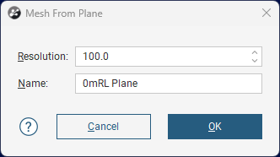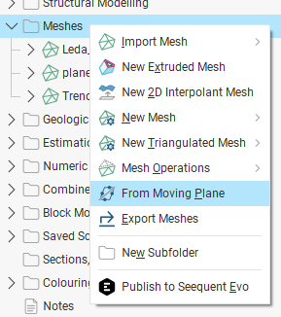
- Under Numeric Models, create a New Distance Function from the RL surface
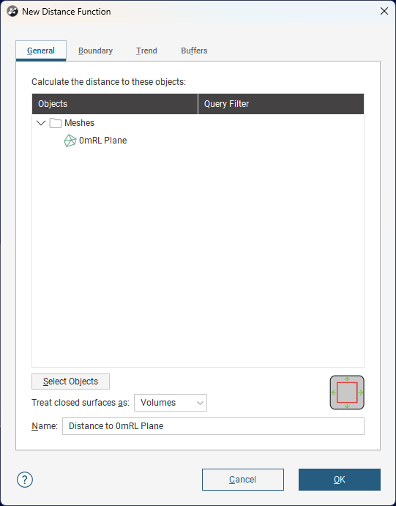
  - (Optional) To reduce processing, give it a boundary similar to your GM/Blockmodel extents.
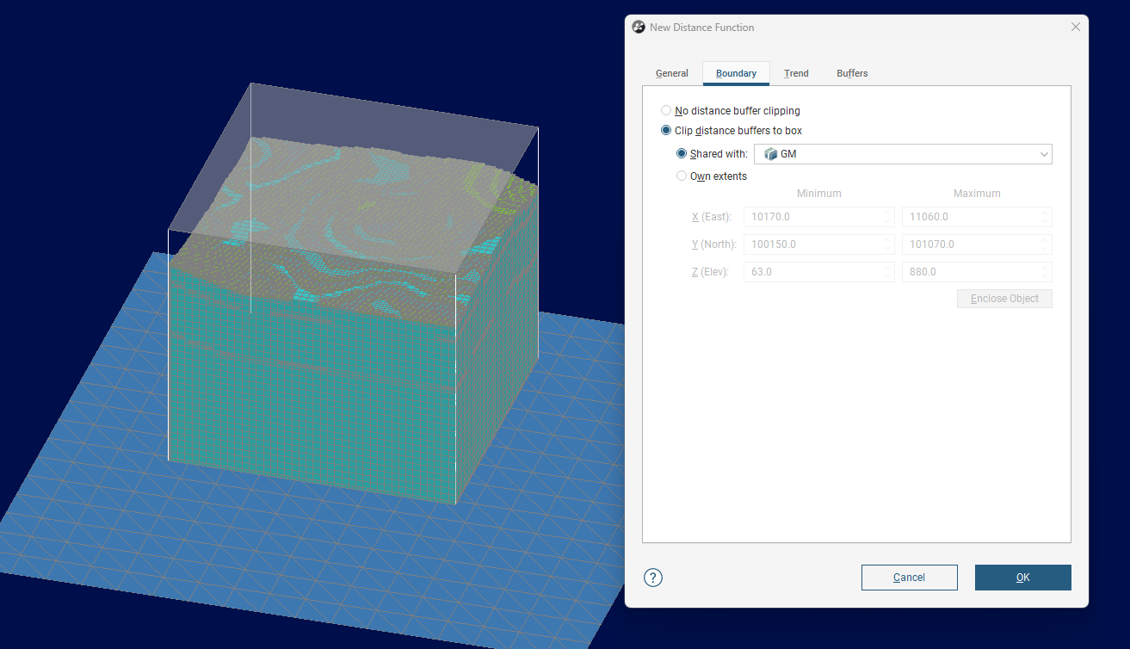

  - Under Buffers, set the Distance objects to match the RL divisions you’d like to report by, the volume type should be ‘Intervals’. Note I’ve increased the default resolution to improve processing time. This will create a series of volumes at each interval, feel free to either extract the meshes or freeze the object to prevent any unnecessary reprocessing.
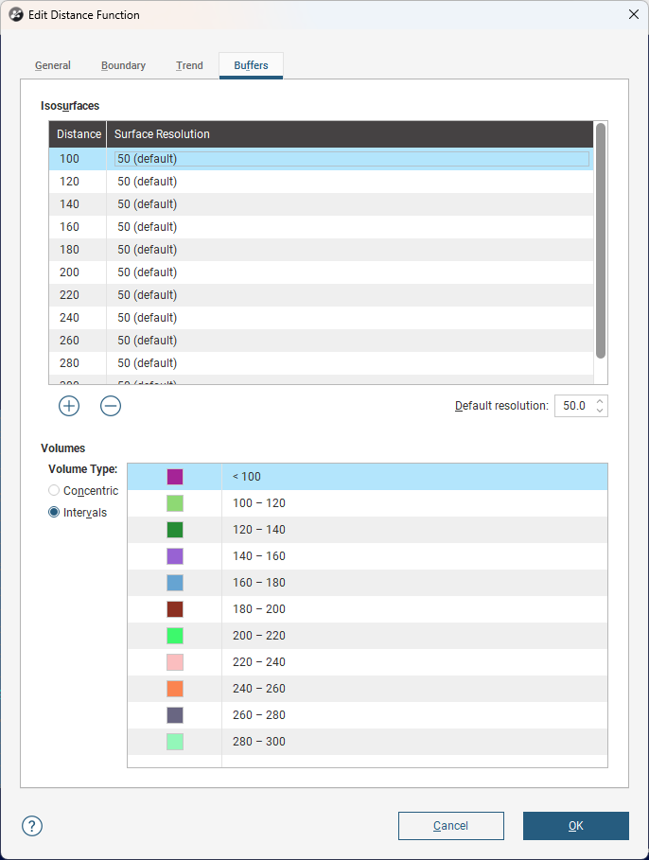
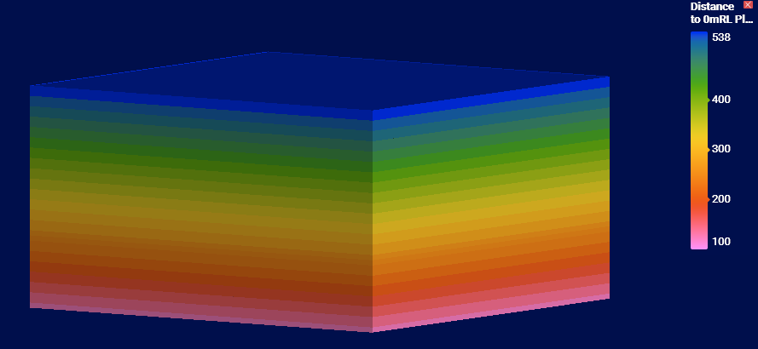

- Under Combined Models create a New Grouped Mesh, then add these volumes to the grouped mesh. The naming convention from the volumes automatically creates a category name that fits its role, however you can edit the Category if you need.
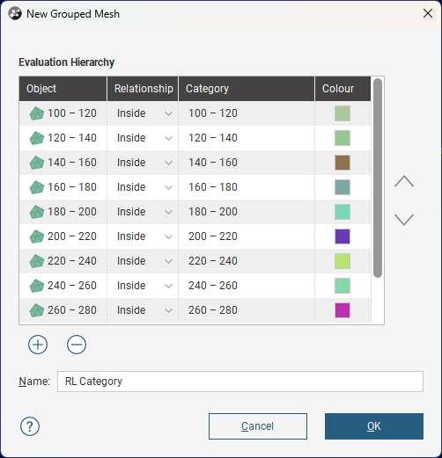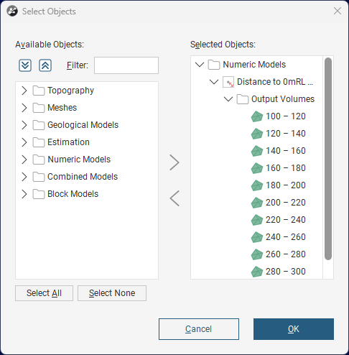

- Now evaluate the Grouped Mesh onto the Blockmodel. Because it’s a category the default is to trigger sub-blocking, however if you want to maintain the parent blocks or the grid falls onto these distance intervals, you can evaluate on Parent or Sub-Block instead to save processing time.
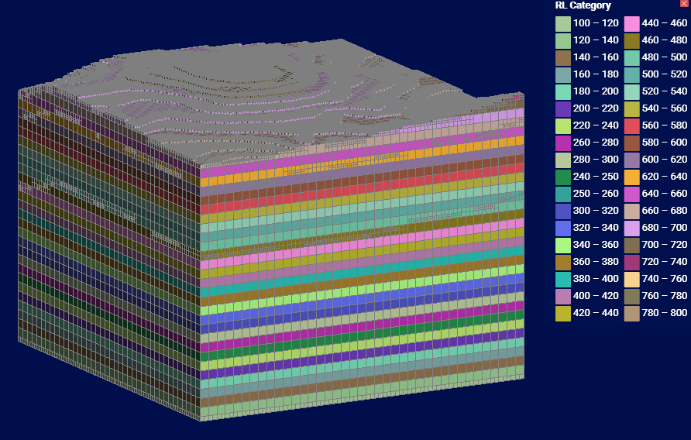
- Now this category can be used in reporting or visualization.

Second Method (Bidirectional RL):
- Establish a plane then mesh at your ‘0mRL’
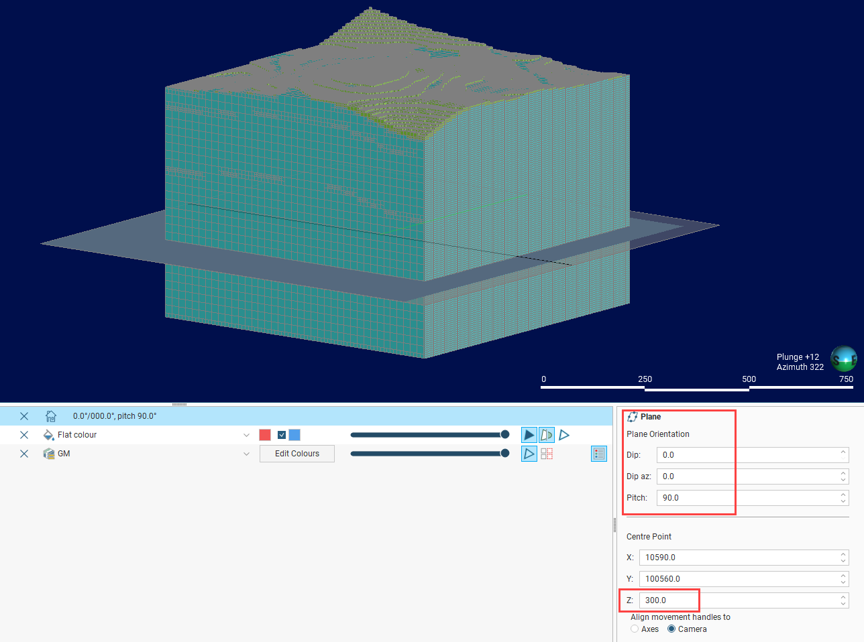
  - Create a flat plane that spans the entire project areal X and Y, with room to spare. Ensure the Z is set to your 0m RL and the Dip is 0

  - Right click on the Meshes à From Moving Plane. This will create a static mesh plane at the correct height.
- Under Numeric Models, create a New Distance Function using the RL surface.
  - Go to boundary, go to the extents for your GM/Blockmodel, then alter the elevation to match the 0mRl plane, this will create a boundary either above or below the plane.
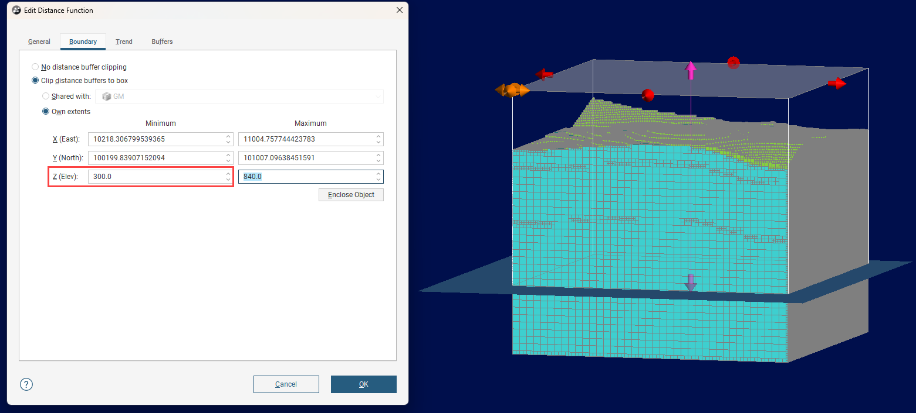
  - Under Buffers, set the Distance objects to match the RL divisions you’d like to report by, the volume type should be ‘Intervals’. Note I’ve increased the default resolution to improve processing time. This will create a series of volumes at each interval, feel free to either extract the meshes or freeze the object to prevent any unnecessary reprocessing.
  - Rename the model to indicate the direction of the boundary
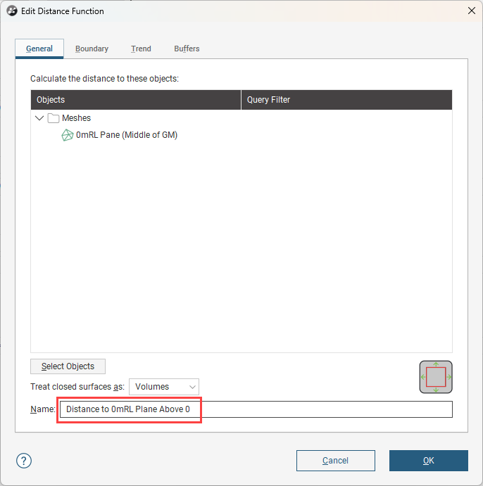
  - Copy the model, rename it to ‘Below’ and change the boundary to match
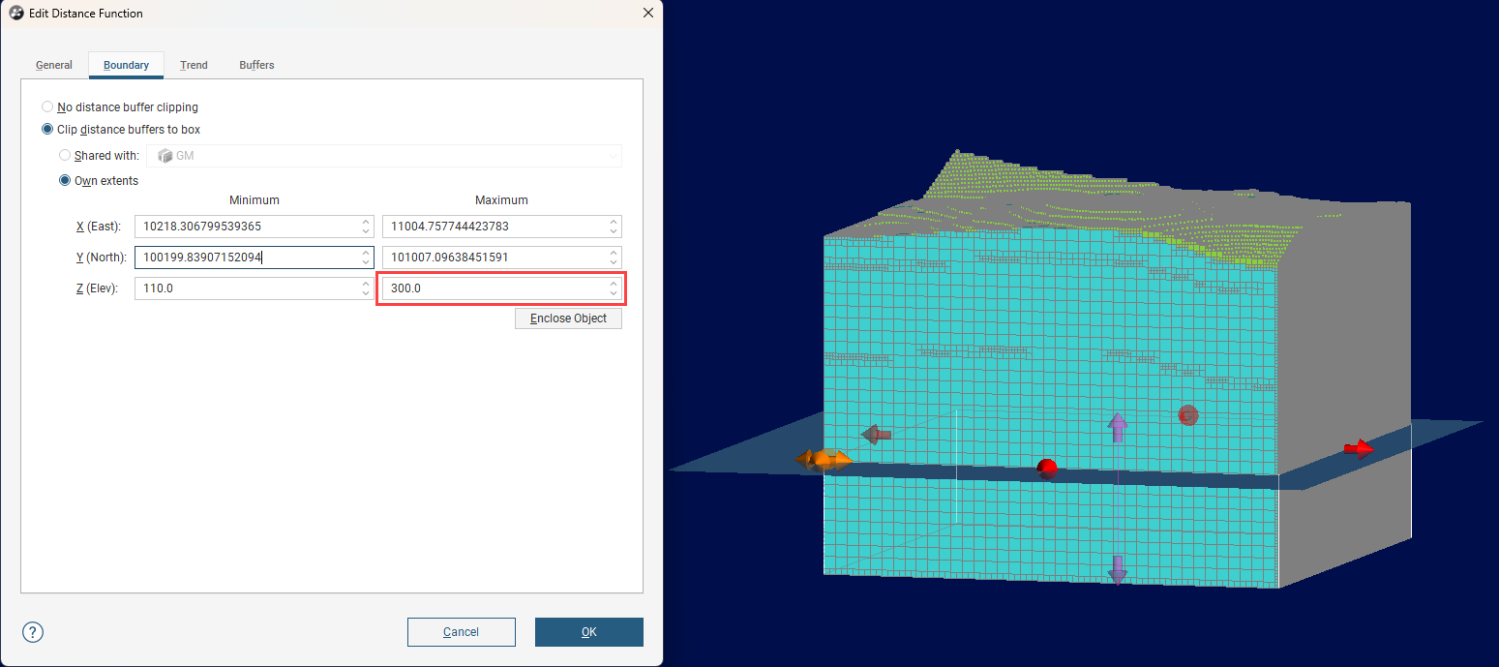

- Under Combined Models create a New Grouped Mesh, then add the volumes for one of the models. The naming convention from the volumes automatically creates a category name that fits its role, however you can edit the Category if you need.
  - Repeat the process for the other Numeric Model, naming it to match the direction.
  - Please note: if there’s a small amount of categories above or below, it may be easier to use one Grouped Mesh and rename the negatives in the category.
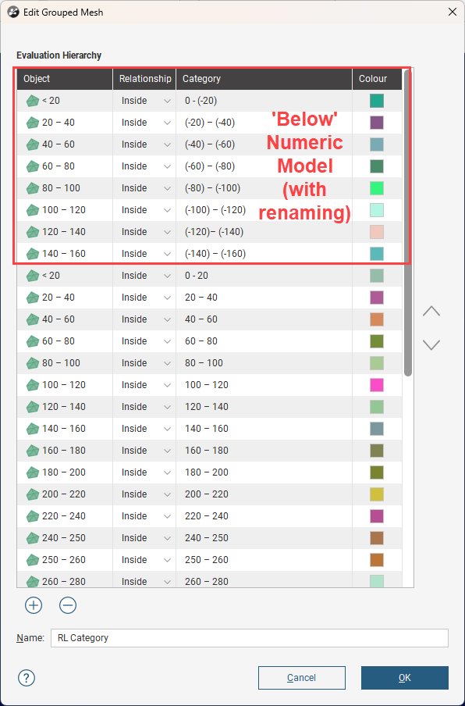
- Now evaluate the Grouped Meshes onto the Blockmodel. Because it’s a category the default is to trigger sub-blocking, however if you want to maintain the parent blocks or the grid falls onto these distance intervals, you can evaluate on Parent or Sub-Block instead to save processing time.

  - The quickest method to combine the above and below values is using a category calculation, with this you can concatenate a negative indicator to the below model.
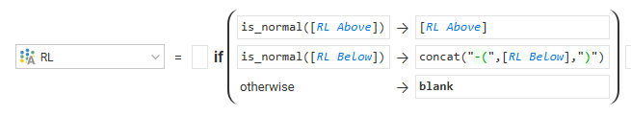
- Now this category can be used in reporting or visualization.
